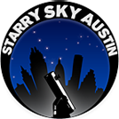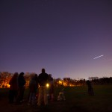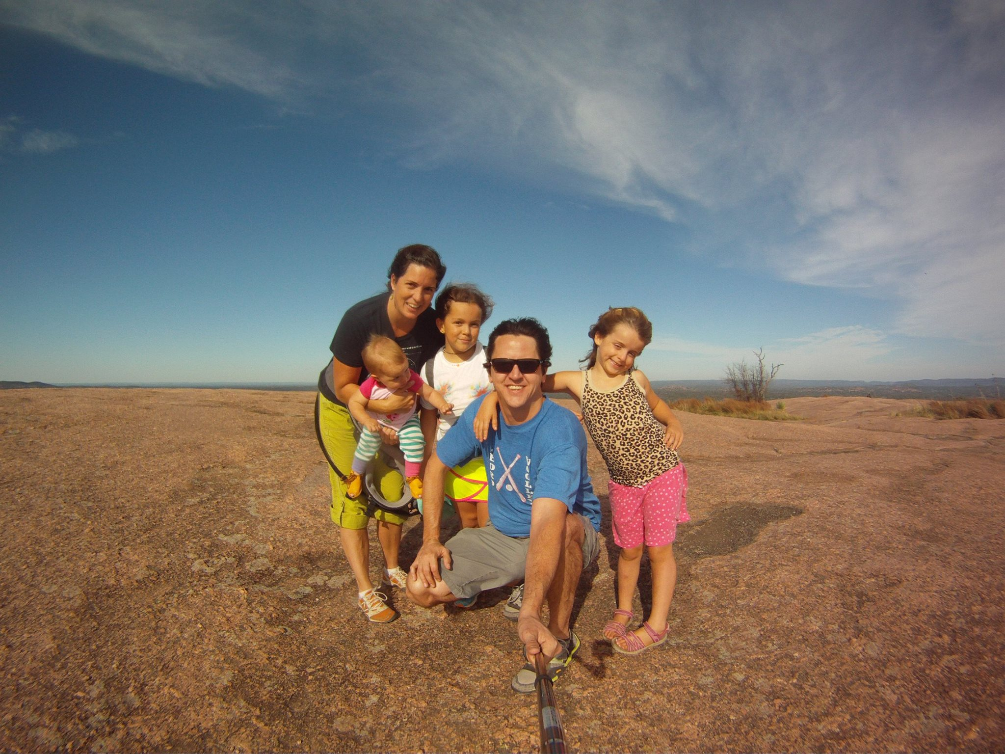
Hands-on Astronomy
@ Your School

Are you curious about the night sky? Do you want to learn how to use a telescope and gain confidence in finding planets, stars and constellations? Join me, Amy Jackson (mother of 3 and astronomy educator) for nighttime stargazing and learn about our night sky and how to use a telescope. We will get to know our telescopes and equipment and then continue the class with a tour of the night sky, view major celestial objects with my 10” telescope and learn how to use a star chart and our Dobsonian telescopes. You will be given a star chart to take home, cut out and keep. This is sure to be a confidence building experience for anyone interested in astronomy.

Who: Students ages 8 and up
When: An evening that suites your group. 7:30-9:00pm. This is weather contingent. It the sky is mostly cloudy we will reschedule.
Where: At your school or nearby park.
Cost: $25. Siblings get a $10 discount. Parents free.

Visit www.starryskyaustin.com for more information or to find out about other class offerings.

To REGISTER for the class:
Pick up a registration form from your school office and/or teacher, fill it out and return it to the office with payment.

